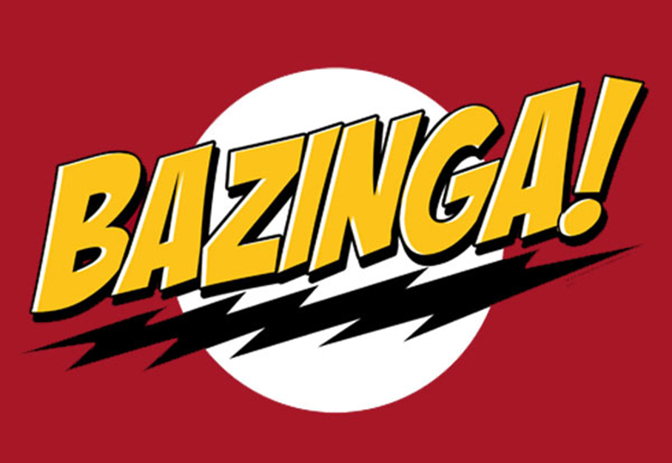

Track Controller Unit Test Report

April 26, 2012

Zhipeng Liu

**1 Introduction**

The unit test tests the TrackController module made by Zhipeng Liu (aka Gilbert).

**2 Test Results**

Passed AddTrackBlockTest

Passed OpenTrackTest

Inconclusive UpdateTest Assert.Inconclusive failed. This method does not return a value*

Passed GetUpdatedTrackStatusTest

Passed CloseTrackTest

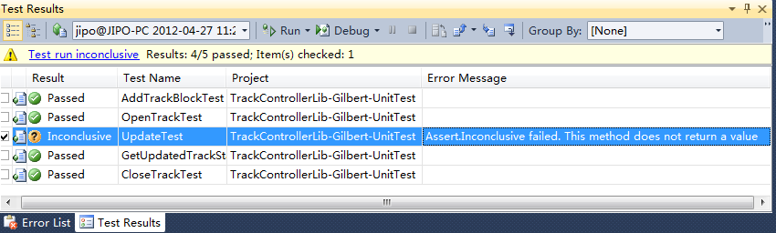

* Function Update() updates the changes of track blocks and switches statuses to a temporary List which is retrieved by the CTC Office, and the function returns nothing.

**3 Problems**

**3.1 Unit test doesn’t cover most of the code**

The unit test only ensures the interface functions work properly, especially when illegal arguments come in, while the internal functions are not tested.

**3.2 Thorough unit test needs other modules**

Fully unit test needs to ensure the code works as expected, but it needs other modules to finish the test. For example, in this case, in order to test TrackController module, at least we need Track module for the data.